Project 2.3.4a Automation Through Programming Project Summary

Team Members:
Mechanical:_____________________________________________________
Electrical:_______________________________________________________
Computer:_______________________________________________________

Project: __________________________ Date: ___________ Section: ________
Mechanical Engineer:
Draw an isometric sketch or two-view orthographic sketch of the model. Label all electrical devices.

Electrical Engineer:
Describe the connections between the controller and electrical device(s) in the diagram below.

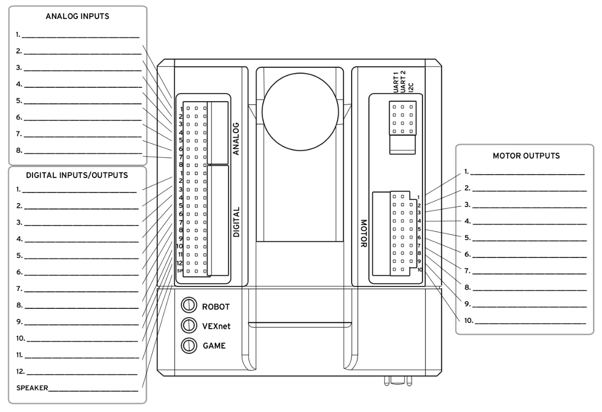
Programmer:
Use the PLTW template to develop the ROBOTC program. Complete all sections of the template then follow your teacher’s direction to submit a digital or print format of the program.

All Team Members: Answer the Conclusion Questions below for each completed project in your engineering notebook.
Conclusion Questions:
- What sensors did you use to solve this problem?

- Was this an open or closed loop system? Why?

- Explain two malfunctions with the solution that your team had to troubleshoot.

4. Describe two responsibilities that you held during this project.

