Activity 2.3.5 Simulated Factory Assembly Line

Introduction
An out-of-state company has purchased a local toy manufacturing company and wants to start making blocks that are used in the international space lab as a multipurpose stabilizer. Your company (class) has been hired to design, program, and assemble a simulated factory assembly line to produce the block. The best design will be used to construct a full-sized automated assembly line.

After looking at the block, you and the rest of the class realize the best approach will be to divide up the tasks and assign teams to design, program, and build a prototype to represent each process to be performed on the block. All of your classmates agree that you will be able to accomplish the task because you have already done several activities that accomplish various tasks and processes that are to be performed on the block. Everyone is anxious to get started.

But wait, the timeline requires the factory to be fully operational on _____________ (insert date your teacher gives you). You must add another shift of employees in order to meet the deadline. This means that you will have to work on the factory project with students in another class. How do you think this will work? How will you communicate what has been done, what needs to be done, what problems you are having, etc., if you are not in the same class? You will have to create an engineer’s project notebook that is left with the project in your classroom so that the next shift of students is kept informed of accomplishments, goals, and problems. The team working on your section of the factory will leave their comments in the project notebook for you to read during your next class.

Equipment
- GTT notebook
- VEX parts
- Computer with ROBOTC program
- Manufactured block
- Simulated Factory Cell Engineering Project Notebook
- Digital camera

Procedure
- Unless your teacher has assigned teams, choose two other people in your class to work with. Discuss with your team the work cell that you would like to create. Your model will simulate the manufacturing of one feature on the part. The processes to choose from include:
- Block entrance cell
- Creating
- slot on top
- slot on side
- top hole
- chamfers on side edges
- chamfers on front or back edges
- side holes
- Painting the entire part
- Delivering six blocks at a time to a pallet at the end of the line for the forklift to pick up and place on truck

- After choosing the process, brainstorm with your team how you will accomplish the task. Using the Simulated Factory Cell Engineering Project Notebook as a guide, document your design process in your engineering notebook. Everyone on the team will take part in all phases of the design process, but one person from each shift will be primarily responsible for the engineering jobs listed below. Each team member is expected to complete a journal entry that documents personal progress, designs, and ideas in your Factory Cell Project notebook every day. Discuss who will assume the primary responsibility for the jobs listed below. Be sure to collaborate with the teams working on cells before and after yours so that you will have a smooth transition in the assembly line.
- Mechanical engineer: Construction and troubleshooting of the workcell
- Electrical engineer: Wiring and troubleshooting of the workcell
- Computer engineer: Writing and troubleshooting the work cell program

- Fabricate, wire, program, and troubleshoot your workcell. When you are sure it works, have your teacher check it. Put it together with the factory cells before and after yours and check them for compatibility.
- When all work cells are functional, put them together and run the completed simulated factory assembly line.
- After a successful run, disassemble your workcell and store all VEX parts in their proper locations.
- Complete self and team evaluation forms, conclusion questions, and the lab write-up. Your teacher will collect your Simulated Factory Cell Engineering Project Notebook and these documents for evaluation.
Conclusion
- What would you have done to improve your workcell?

- What was your team’s greatest challenge with its workcell?

- What did you do to contribute to your team’s success?

4. Is there anything you could have done differently to ensure your entire class had success with the simulated factory cell project?

Activity 2.3.5 Evaluations
Self-Evaluation
Your Name __________________________ Section _________

5 = Great 4 = Very Good 3 = Good 2 = OK 1 = Needs to Improve
Attendance  Employers are concerned with the attendance of employees. Was your attendance acceptable? | Evaluation:  Comment:
Participation  Did you do a fair share of the work while in class? | Evaluation:  Comment:
Keeping to the Task  Did you stay at the work area and try to help?  Did you keep the conversation on task? | Evaluation:  Comment:
Evaluating Listening Skills  Did you look at others when they were talking to you?  Did you listen when others were talking?  Did you respond in a positive manner? | Evaluation:  Comment:
Totals

Comments:

Team Evaluation
Evaluator’s Name __________________________ Section _________

5 = Great 4 = Very Good 3 = Good 2 = OK 1 = Needs to Improve
 | Your Shift Team Member: | Your Shift  Team Member: | Other Shift  Team Member:
Attendance  Employers are concerned with the attendance of employees. Is the attendance of the members on your team acceptable? | Evaluation:  Comment: | Evaluation:  Comment: | Evaluation:  Comment:
Participation  Did team members do their fair share of the work while in class? | Evaluation:  Comment: | Evaluation:  Comment: | Evaluation:  Comment:
Keeping to the Task  Did team members stay at the work area and try to help?  Did they keep the conversation on task? | Evaluation:  Comment: | Evaluation:  Comment: | Evaluation:  Comment:
Evaluating Listening Skills  Did team members look at you when you talked to them?  Did they not talk when others were talking?  Did they respond in a positive manner? | Evaluation:  Comment: | Evaluation:  Comment: | Evaluation:  Comment:
Totals

Team Members:
Mechanical:_____________________________________________________
Electrical:_______________________________________________________
Computer:_______________________________________________________

Project: __________________________ Date: ___________ Section: ________
Mechanical Engineering:
Draw an isometric sketch or two-view orthographic sketch of the model. Label all electrical devices.

Electrical Engineering:
Describe the connections between the controller and electrical device(s) in the diagram below.

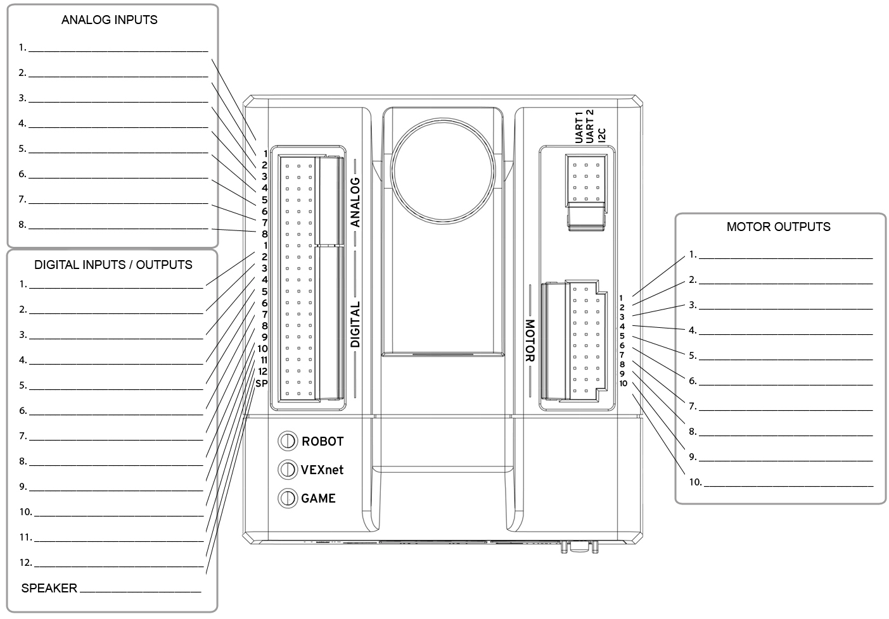

Computer Programmer:
Print and attach the ROBOTC program. Make sure you use the PLTW template and complete all sections.

